Overview
The practice of project management is part art, part science, and a lot of discipline. Project management requires listening, asking good questions, planning, prioritizing, communicating, motivating, analyzing, tracking, re-prioritizing, and a big dose of other work that most people do not make time to do. Good project managers make the time, and use tools to help them do their work more efficiently. Microsoft Project and Project Server are designed to help project managers do their job more efficiently.
Microsoft Project Server is a system of integrated project and portfolio management tools. Project Server is more than just an enterprise project scheduling tool. It is also a communication and collaboration portal for project teams. It is also a central repository for all project data, documents, and discussions.
Project Server is a very robust system. Users often struggle with Project and Project Server if they lack a good overall understanding of this system. There are certain features, work flows, and functions in Project Server that only make sense in the context of what they were designed to do, which is support project management across an entire organization.
In Understanding Project Server as a Project Management Tool we provide you with an overview of the features of Project Server that are designed specifically with the project manager and the project team in mind. Once users understand the purpose for which features of Project Server were designed, then they make more sense.
We will look at the following:
- Leveraging Technology for Project Management
- Different Project Lifecycle Approaches
- SharePoint, Project Client and Project Server
- Resource Management
- Managing with a Shared Resource Pool
- Forecasting Workload and Resource Availability
- Tracking and Managing Planned vs. Actual
Upon completion of this chapter, the participant will be able to:
- Create, publish and manage project schedules with Project and Project Server
- Work with an Enterprise Global Resource Pool
- Manage project teams using Project Web Access and Project WorkSpaces
- Use SharePoint Services and Project Server to coordinate communications around projects

Project Lifecycle Management
Figure 1-1 is a flowchart that illustrates the big-picture flow of the project management lifecycle.
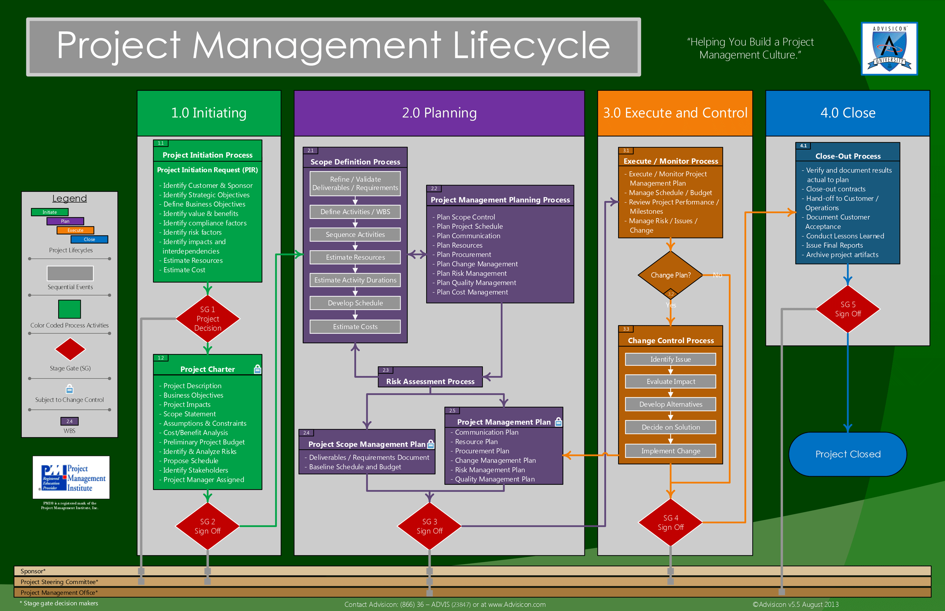
- Project Management Lifecycle Flowchart [Project-Management-Lifecycle.png]

Leveraging Technology for Project Management
Why use Microsoft Project Server 2013?
Projects are becoming a strategic focus for many organizations, who are projectizing many different activities and initiatives:
- New product and service development projects
- Process improvement projects
- Policy and organizational development projects
- Technology development and implementation projects
- Focused activities to deliver specific outcomes for clients
Organizations are pursuing a greater number and wider variety of projects every day. For some organizations, projects are a small, but important, part of their business. Many organizations are projectizing their strategic work—so they can more effectively focus on key initiatives.
For others, projects ARE their business. From architects, builders, engineers and construction companies to marketing teams, IT organizations, and software developers—projects define their work.
The demand for effective, consistent project management has grown rapidly over the last decade. Project management has rapidly become a core area of management knowledge and practice. The role of “Project Manager” has become very common in organizations.
The field of project management focuses on answering the question: What are the processes that lead to successful projects. Project management is essentially process-focused: How to do projects right.
Figure 1-2 shows the processes involved in the project lifecycle and how they connect.
- Project Management Lifecycle Processes [lifecycle processes.jpg]
Complex management processes require tools to manage them. People tend to use what they have available and already understand. This is why Microsoft Excel is often used in smaller project management initiatives. For many projects, Excel is a sufficient and powerful tool.
However, it does not take much complexity (multiple interrelated schedules, resources, requirements, deliverables, and departments) to exceed Excel’s project management capabilities. Advanced software applications have been developed to support and facilitate many levels and styles of project management. These applications range from simple, high-level schedules to complex, integrated enterprise solutions.
Project management processes can become very complex. One of the risks of complex processes is that they tend to be ignored in practice, resulting in inconsistent results, idiosyncratic management, and frustration.
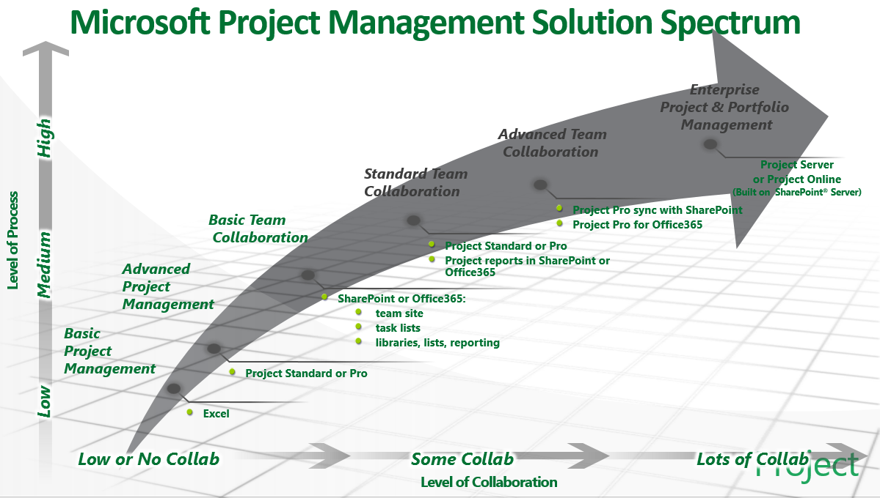
- Microsoft Project Management Solution Spectrum [PPM Lifecycle.tif]
The diagram above illustrates the migration from low or no collaboration (the X axis) with the Level of Process needed (Y axis). As the project to portfolio level of maturity increases and the need for more collaboration (beyond one or two people to many) grows, so does the technical solution.
Strategic project management methods and consistent project management processes need tools designed specifically to support them to be truly efficient and effective. The leading application on the market that has been designed specifically to support project management is Microsoft Project. This desktop application is part of Microsoft’s popular Office Suite.
Microsoft Project is a powerful relational database program that can be configured for use on a single client PC or in networked environments. But its capabilities to facilitate and automate enterprise-wide project management processes are limited. For organizations that are seeking an integrated, enterprise-wide project and portfolio management solution, Microsoft has developed Microsoft Project Professional and Microsoft Project Server.
What is Project Server 2013?
Microsoft Project Server 2013 is the fifth generation of Microsoft’s server-based enterprise project management technology which integrates with Microsoft Project Professional.
Project Server is designed to support a process-driven project management organization. Project Server can be configured to automate many project management processes, especially schedule tracking and communication. Project is the primary scheduling engine in which project managers create project schedules, deliverables, task assignments, and task notes that are viewed and shared by project team members through Project Web Access (PWA). Project's dynamic scheduling engine allows users to model “what-if” scenarios, and immediately see what different changes will impact in their projects. Project Server allows users to see these impacts across an entire enterprise.
Project Server 2013 allows task assignments that are created in Microsoft Project 2007 and 2013 to be communicated automatically via Microsoft Office Outlook 2007 or 2013, and visual reports to be generated in Excel and Visio, thus leveraging the entire suite of Microsoft's Office 2007 and 2013 Suite of applications. By leveraging the power of the SharePoint environment and a close integration with other Microsoft Office applications, Project Server enables project and management teams to communicate and collaborate on projects, forecast and run what-if scenarios, and analyze plans (baselines) versus actual historical data across their enterprise.
Some primary values of Project Server to an organization are:
- Visibility of all resource assignments and allocations across an entire enterprise.
- Central SQL database repository of all projects in an organization’s portfolio of projects with advanced reporting and analysis features.
- Automated communications of project assignments and updates.
- Roles and rules-based access to project information.
- SharePoint-based collaboration portal for project activities.
- Integrated with Microsoft’s Office 2013 applications (especially Outlook, Excel and Visio). Analysis Services using OLAP cubes, and many more options leveraging SQL Reporting Services.

Overview of the Microsoft EPM Solution
Understanding Project Sever as a project management tool helps many users discover Project Server’s value to their organization and why they are being asked to use it. This section provides an overview of where Project Server fits into the Microsoft Enterprise Project Management (EPM) solution.

Microsoft Project Standard
Microsoft Project Standard is a stand-alone project management desktop application. Project Standard can be used on a network with a shared resource pool, which allows for easy access to a shared Resource Pool, but this set-up is very prone to corruption of the Resource Pool. Project Standard does not connect to Project Server.

Microsoft Project Professional
Microsoft Project Professional is the desktop project management application that connects to Project Server. Most of the data that can be accessed via Project Server originates in Project Professional. Project data has to be 'published' to Project Server to be accessible via Office Project Web Access.

Microsoft Project Professional for Office 365 (Online)
Microsoft Project Professional for Office 365 is the same version of Microsoft Project Professional, but it is accessed via the cloud and is a subscription Software as a Service (SaaS) or streaming product.
Project Pro for Office 365 is delivered as a subscription through Office 365, Project Professional for Office 365 is the Microsoft Cloud delivered version of Project Professional. With Project Pro for Office 365, software automatically stays up to date (with options for customizable policies). You can access Project Pro for Office 365 from virtually anywhere on any Windows PC by streaming the complete desktop client with Project on Demand.
Project Pro for Office 365 is the advanced project management and resource management application that connects to Project Server. Most of the data that can be accessed via Project Server originates in Project Professional. Project data has to be 'published' to Project Server to be accessible via Office Project Web Access.

Microsoft Project Online
Microsoft Project Online 2013 is an enterprise project management system that is fully cloud based. Whether that is public or privately hosted, you are able to leverage the enterprise version of Project Server Online through SaaS.
Project Online with Project Pro is an all-in-one subscription that delivers the full spectrum of project management capabilities — from task management for teams to project management to project portfolio planning. With the ability to access Project from virtually anywhere through Office 365 cloud services, team members can manage their tasks as easily as pressing a check box on their smartphone browser and managers can check reports on the go with just a swipe on their wirelessly connected tablet device.
Project Online is an integration of a SQL database with two clients: Project Professional 2013 (Client or Streaming) and Project Web Access 2013. Microsoft Project Web Access 2013 (PWA) is the browser-based user interface that allows users to access the central repository, Microsoft Project Online. PWA is the interface for the SharePoint collaboration portal where data from published Microsoft Project Professional 2013 schedules are stored.

Microsoft Project Server
Microsoft Project Server 2013 is an enterprise project management system. It is an integration of a SQL database with two clients: Project Professional 2013 and Project Web Access 2013. Microsoft Project Web Access 2013 (PWA) is the browser-based user interface that allows users to access the central repository, Microsoft Project Server 2013. PWA is the interface for the SharePoint collaboration portal where data from published Microsoft Project Professional 2013 schedules are stored.
Figure 1-3 illustrates Project Server communication workflow.
- Project Server Task Assignment and Update Work Flow [MS-workflow-diagram.jpg]
Microsoft Project Server 2013 is positioned to provide tactical EPM views and project management capabilities. Project Server can also be integrated with Microsoft Project Portfolio Server, Windows SharePoint Services 3.0, Microsoft SharePoint Server (MOSS), and Microsoft InfoPath.

SharePoint Front End
Project Server 2013 provides a rich set of browser-based functionality through its component Office Project Web Access, a Microsoft ASP.NET application that uses Project Server Web services through Microsoft Internet Explorer and Project Server Web Parts in Windows SharePoint Services 3.0.
Project Web Access is built on Windows SharePoint Services 3.0 and offers all of the advantages of WSS 3.0, such as a rich browser experience by using AJAX development techniques and the Web Part and Integration framework. The web-based client software, Microsoft Project Server 2013, is accessible through Project Professional 2013 and other Win32 API–based clients such as the Microsoft Visual Studio development system.

Project Server Gateway Middle Tier
Project Server 2013 provides a real application server that includes the Project Server Interface (PSI), discrete business objects, server-side events, a common data access layer (DAL), and queuing services. The PSI provides web services that can be consumed by other applications. Project Server 2013 and Project Portfolio Server are connected through the middle-tier components. This out-of-the-box connection is known as the Project Server Gateway, a bidirectional link that enables administrators to associate multiple Project Servers to Project Portfolio Server, providing executives with a consolidated view of all projects within the organization.

SQL Server Back End
Both Project Server 2013 and Project Portfolio Server use SQL Server 2000 SP4 or SQL Server 2005 SP1. Project Server 2013 takes advantage of some of the new features in SQL Server 2005, such as security enhancements and improved Analysis Services and Reporting Services.

Microsoft Project Portfolio Server
Microsoft Project Portfolio Server (comes with Project Online or Project Server), helps organizations identify, select, manage, and deliver portfolios of projects. The goal of this EPM solution is to align an organization's projects with its strategic priorities. Project Portfolio Server is a key component of the Microsoft Enterprise Project Management (EPM) Solution.

SQL Server and Integration with Line of Business (LOB) systems
Microsoft has extended Project Server's value by building it on Microsoft SQL Server business intelligence technology. This also allows Project Server 2013 to share databases with many other applications. This improves collaboration, reporting, and analysis. Easier integration and extensibility of information has also been enabled by the technology upgrade to Microsoft Visual Studio 2005. SQL Server Integration Services, SQL Analysis Services, SQL Reporting Services, and SQL Server Business Intelligence Development Studio can all be used to streamline productivity.

SQL Reporting Services
By being built on a SQL database, Project Server leverages SQL Server Reporting Services. This comprehensive, server-based solution enables the creation, management, and delivery of both traditional, paper-oriented reports and interactive, web-based reports. SQL Reporting Services is an integral part of the Microsoft Business Intelligence framework. SQL Reporting Services combines the data management capabilities of SQL Server and Microsoft Windows Server with familiar and powerful Microsoft Office System applications to deliver real-time information to support daily operations and drive decisions.

Different Project Lifecycle Approaches
The project management discipline has developed into a core area of organizational management. Different industries have developed project management methodologies that address their specific workflows and issues. Architects, construction companies and property developers have developed a set of project lifecycles that reflect certain standard processes from land planning and acquisition, to permitting and design requirements.
The rapid growth of the project management field has spawned a number of professional associations. The Project Management Institute (PMI) is the largest project management professional association in the world today and it is growing rapidly. The most widely used standard for project management has been developed by the PMI.

PMI’s A Guide to the Project Management Body of Knowledge
PMI has developed a very extensive library of project management standards, references and tools. PMI has collected the most comprehensive reference on project management standards in a book called A Guide to the Project Management Body of Knowledge (PMBOK® Guide) - affectionately called “The PMBOK” (pronounced “PIM-bok”).
The PMBOK® defines a certain standard for project management practices, which many industries follow. Project Server 2013 has been developed to support a range of PMBOK-aligned project management approaches. It can be configured to support both Scrum and Agile approaches, but organizations employing these methodologies need to adjust their use and expectations of Project Server as a scheduling and management vehicle.

Technical Lifecycles (Agile to Scrum)
There are other approaches to project management that have been developed by and for project managers in different fields and industries. Two approaches used fairly widely in the technology sector are called Scrum and Agile.
The software development and technology industries have developed approaches to project management that reflect the need for short design-build iterations to facilitate integrating emerging requirements into new product development processes. These tend to focus on shorter iterations and progressive requirements definition.
It might be said that where the PMBOK methodology focuses on thorough planning before project execution, Scrum and Agile focus on minimizing the time between project initiation and execution, and repeated cycles of design, build, test, redesign, rebuild, and test.

Industry-specific Lifecycles
Some industries and fields that have developed their own project management methodologies and lifecycles include construction, architecture, IT, software development, and property development. Project and Project Server are configured so that they can utilize and support many different project management processes, especially those applicable to projects with longer project timelines.

Using SharePoint, Project Pro and Project Server
How do the different elements of the Enterprise Project & Portfolio Management (PPM) system work together?
A project manager first creates a project schedule in Microsoft Project Professional on an individual PC (client level). The project manager saves and publishes the schedule to Project Server. The project schedule now resides on Project Server. Upon publishing, Project Server automatically sends e-mail notifications to those who have been assigned tasks on the project schedule (a common configuration).
After a project schedule has been published, project managers and team members assigned to tasks in that project can log on to their Project Server account through Internet Explorer (version 7.0 and newer) and view their tasks, projects, and other information through Project Web Access (PWA) – the web-based graphic user interface for Project Server. Project Server 2013 and PWA have been designed to work entirely in a SharePoint environment, which provides a very rich and flexible environment for project team member collaboration from anywhere in the world via Internet Explorer.
Project Managers are then able to view the entire portfolio of published projects and manage their projects, resources, task updates, time sheets, status reports, and other activities through PWA. PWA also provides a quick and easy way to see multiple views of their projects from different screens. Project views are a strategic way to identify the current status of projects. Resource views are helpful for assessing resource availability and overallocations.
PWA offers project managers many stock views, and the flexibility to create many custom views, all of which can easily be exported to Excel for deeper analysis. The reporting functions of PWA are very robust and provide a wide range of options.
Project Server can be configured to automatically create new Project Workspaces for each new project that is published. Project Workspaces are special SharePoint sites designed specifically for projects published in Project Server. A Project Workspace serves as the central collaboration site for everyone with an interest in a project.
Project managers and team members can leverage Project Workspaces for sharing project documents, managing risks and issues, and participating in shared discussions in one central location where all project participants can find everything relating to their project, including a view of the project schedule and many other Web Part options.
Documents stored and shared in a Project Workspace for shared access increase the level of data consistency impossible with files saved on individual drives or in folders on a network. Shared Documents are accessible based on permission and security settings. They have to be checked out for editing, which helps provide version control, maintaining the integrity of project documents. Project Workspaces also provide a site for creating, sharing, communicating and managing risks and issues.
One of the most powerful features of Project Server is the enterprise resource pool. Project Server uses a shared enterprise resource pool, which can be synchronized with Active Directory. The enterprise resource pool allows project and resource managers to see the availability and allocations (and overallocations) of all the resources in the organization in a single view.

Managing with a Shared Resource Pool
Using the enterprise resource pool, project managers can build a project team for each project to whom they can assign tasks in a project schedule. Using the enterprise resource pool, Project Server automatically reflects the working and non-working time of each resource, giving a project manager an accurate view of the impact to the schedule of each resource assignment.

Tracking and Managing Planned vs. Actual
Project and Project Server give project managers and teams the ability to create project schedules and save baselines that reflect their original plans. After saving and publishing their schedules, project managers are able to use the EPM system to track and update the actual progress of the project against their plan (baseline).
These features give project managers and organizations the ability to compare and analyze project performance. This data can help guide lessons-learned sessions, process improvement projects, team reviews, and even performance bonuses.

